**Day 10 Assignment**

Statement 1:

Skewness of Monthly Income is Positive:

i.e. more people have lower salaries

Proof:

Statement 2:

Years at Company and Years since last promotion are Positively Skewed:

i.e. more people have joined not long ago but have recently received a promotion.

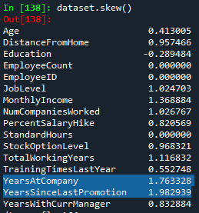Proof:

Statement 3:

Percent Salary Hike has a positive skew (more people have smaller hike), with a mean of approx. 15%

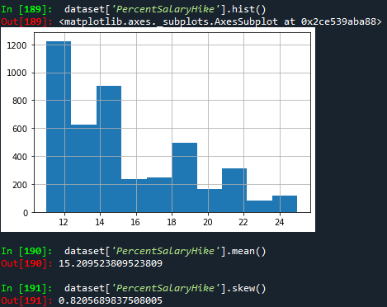Proof:

Statement 4:

Most people Travel Rarely, some travel Frequently and approximately half the no. of those don’t travel

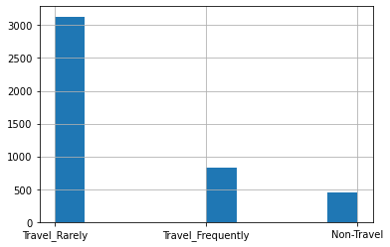Proof:

Statement 5:

There is a positive skew in Distance from Home

i.e. most people stay near to the office

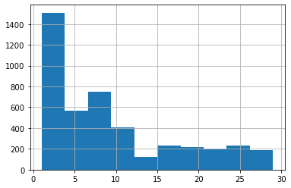Proof:

Statement 6:

Most employees are Married, followed by Single and then Divorced

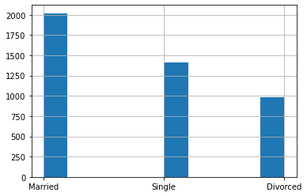Proof:

Statement 7:

Total Working Years has a positive skewness and is Leptokurtic

i.e. Most and a high number of employees has lower Experience (<15 years) in total

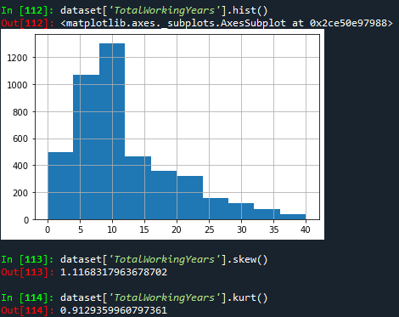Proof:

Statement 7:

Years since last promotion has a high positive Skewness

i.e. most people received a promotion recently (<2 years)

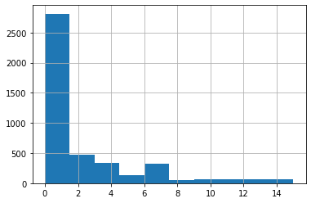Proof:

Statement 8:

Age has a slight Positive skewness, but is pretty much normal, with most of employee in range of 30 years and 40 years old

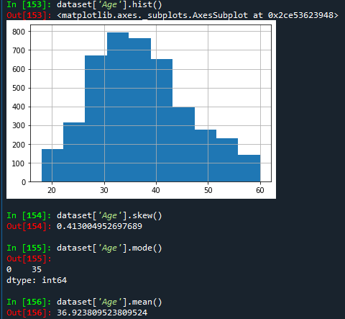Proof:

Statement 9:

The Number Companies Worked has a positive Skewness, most people (mode) they have worked in 1 company before (this is 2nd company) , but on average (mean) people have Worked in 2-3 companies (this is 3rd-4th)

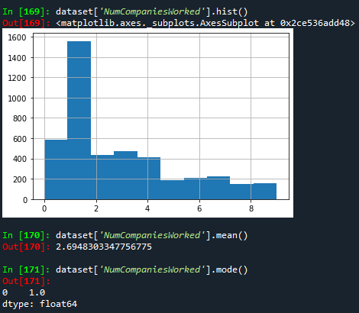Proof:

Statement 10:

About 16% employees are choosing for Attrition

Proof: